BOWLING DISMISSALS
SE Bond
Bowling dismissals by %
33.33
6.67
40.00
20.00
0.00
10.00
20.00
30.00
40.00
50.00
b
lbw
ct
ct k

HK Bennett
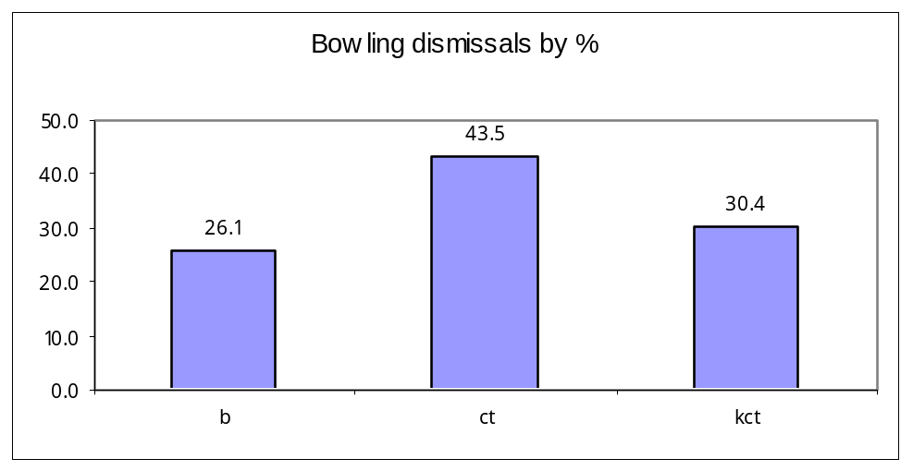

LM Burtt
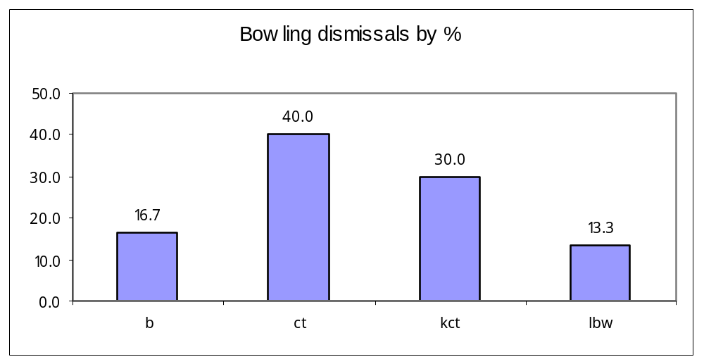

BC Hiini
Bowling Dismissals by %
36.84
36.84
10.53
10.53
5.26
0.00
10.00
20.00
30.00
40.00
b
ct
kct
lbw
st

RD Burson
Bowling dismissals by %
27.0
13.5
37.8
18.9
2.7
0.0
10.0
20.0
30.0
40.0
b
lbw
ct
kct
st

BATTING DISMISSALS
SL Stewart
Batting dismissals by %
15.5
41.4
15.5
13.8
13.8
0.0
10.0
20.0
30.0
40.0
50.0
b
ct
kct
lbw
ro
IA Robertson
Batting Dismissals by %
35.00
35.00
15.00
10.00
5.00
0.00
10.00
20.00
30.00
40.00
b
ct
kct
lbw
st

MHW Papps
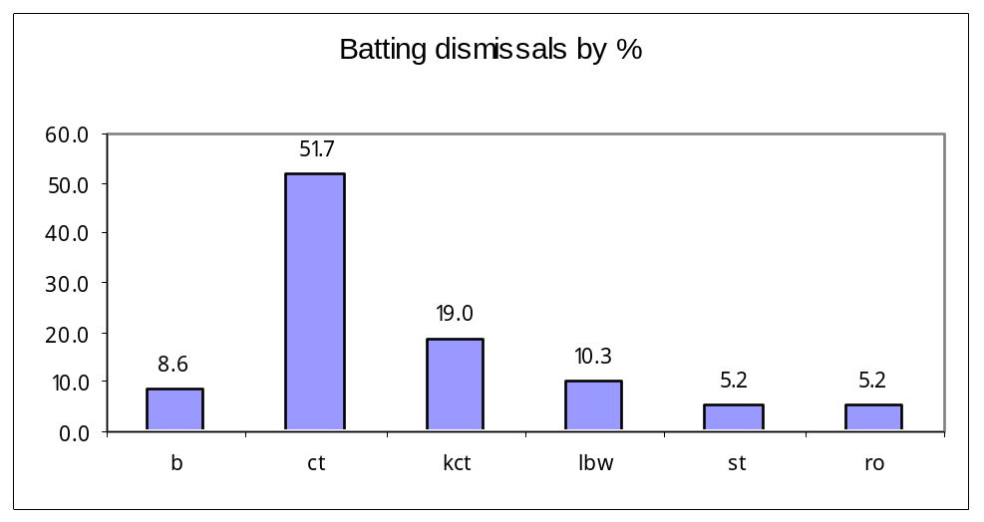

JG Myburgh
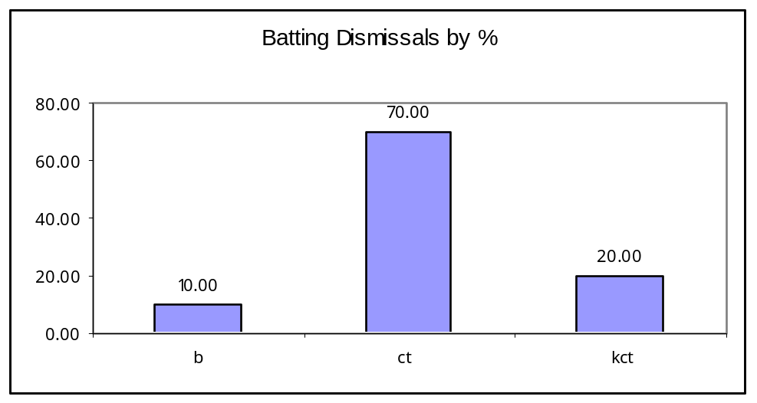

CZ Harris
Batting Dismissals by %
24.4
47.7
11.6
3.5
1.2
11.6
0.0
10.0
20.0
30.0
40.0
50.0
60.0
b
ct
kct
lbw
st
ro

PG Fulton
Batting dismissals by %
29.0
35.5
16.1
12.9
6.5
0.0
10.0
20.0
30.0
40.0
b
ct
kct
lbw
ro

AM Ellis
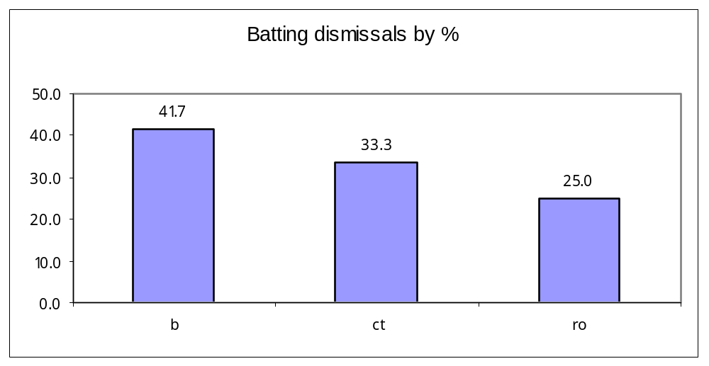

CFK Van Wyk
